**Information Retrieval using NLP**

**Business Objective:**

Based on the text question, NLP algorithm should retrieve 5 most relevant responses from the corpus with rankings (Probabilities)

**Data Set Details:**

qa_Electronics.json

**Acceptance criteria:**

An interface to which takes text as input, in the backend NLP algorithm retrieves top 5 answers.

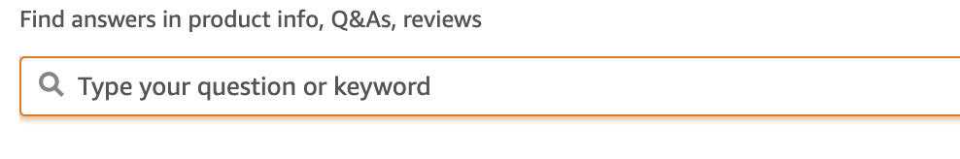

Then the response would be

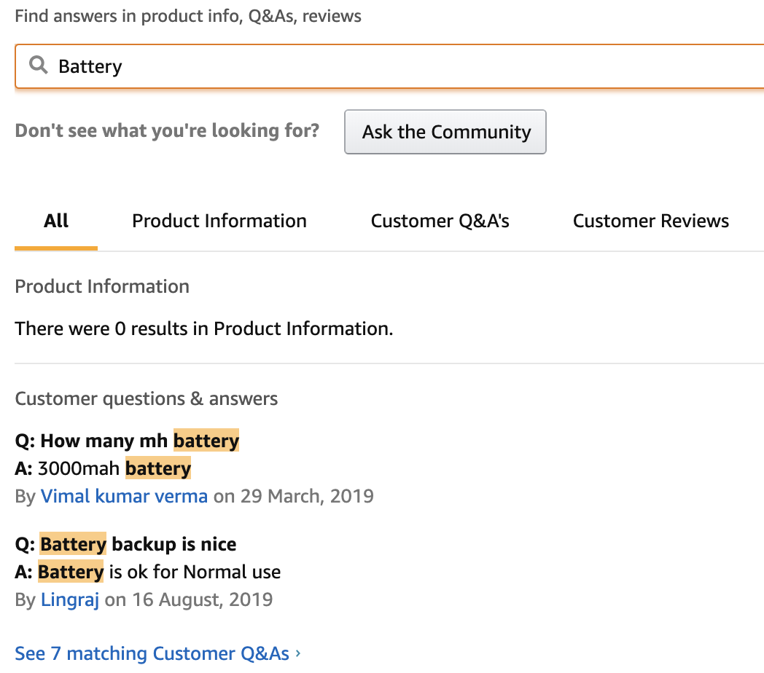

**Milestones:**

65 days to complete the Project

|  |  |  |
| --- | --- | --- |
| **Milestone** | **Duration** | **Task start - End Date** |
| Kick off and Business Objective discussion | 1 day |  |
| Data set Details | 1 Week – 1 ½ week |  |
| EDA | 2 Weeks – 2 ½ week |  |
| Model Building | 1 Week – 1 ½ week |  |
| Model Evaluation | 1 week |  |
| Feedback |  |
| Deployment | 1 Week |  |
| Final presentation | 1 day |  |